

**FINAL REPORT CSE 326**

**TOPIC : Car selling and buying**

***SECTION :*** K19GE

***SUBMITTED BY:***

***GROUP MEMBERS***

***Name***  ***Regd no. Roll no***

Priyanshu 11908120 31

Ravinshu Makkar 11908152 32

Ketan Nalwaya 11908169 33

***SUBMITTED TO:***

Ms. Manu Bali

**INDEX**

1.Introduction

2.Aim of this website

3.Purpose

4.Function of this website

5.website screenshots

6.Drawback

7.Member contribution.

***INTRODUCTION***

Selling your vehicle through online system can be the easiest and the most profitable option. The process of its work is almost same as that of the traditional medium, and you will never become confused. However, the most important point is that there are many websites that will allow you to**sell your car online for free.** Thus, you can post your advertisement without investing any money. But the time it takes to sell a car privately ranges from a few hours to never. It is because of the countless factors which influence the decision making process. However, if you start out with right price and expectations then it becomes easier for you to **sell your car**. Internet is thus the most user-friendly option that can give you the best car selling experience.

***Aim of this website***

Before the introduction of internet, people used to sell their cars through newspaper or local magazine. Though the conventional medium was easy to understand, the seller used to get very limited audience. Now, the websites for buying and **selling the car** help you reach vast number of potential customers.

Our aim is to create an effective, detailed website that caters the requirements of all the customers. The website should be easily handled, efficient and user friendly.

***Purpose of this website***

* **Sell your car in one visit.**
* **Best car price.**
* **Instant payment and we also accept payment on delivery.**
* **Free RC transfer.**

***Function of this website***

* The website will accept customer orders.
* The website will able to accept selling request.
* 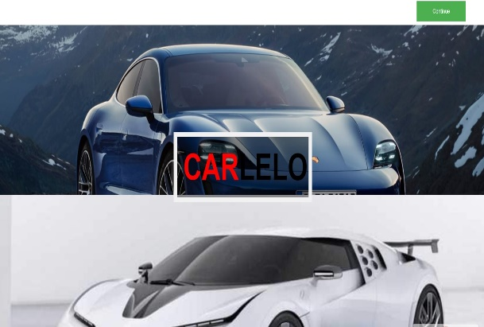 Customer can give their valuable feedback.

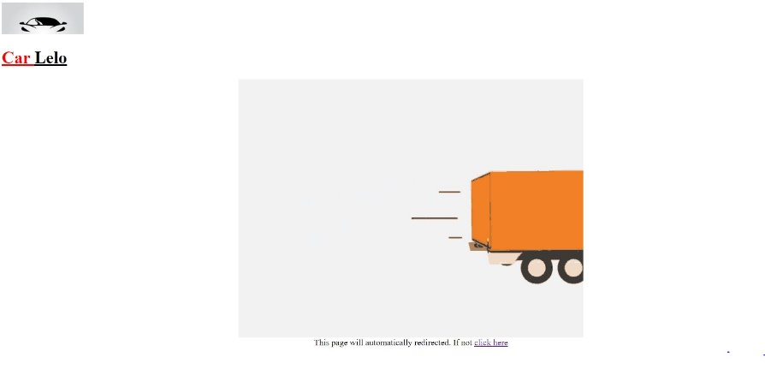

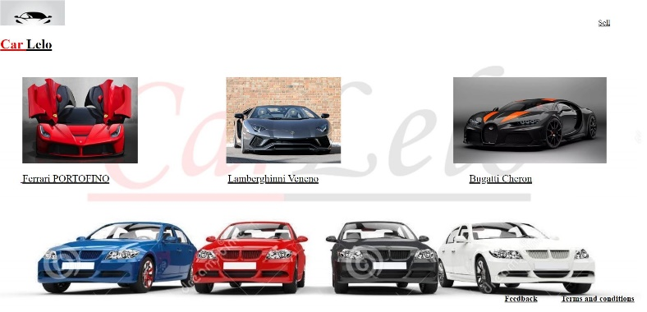

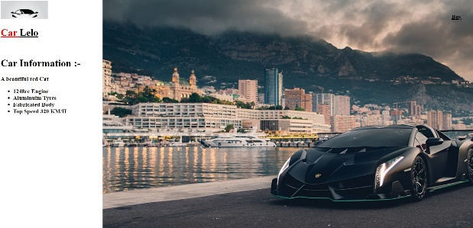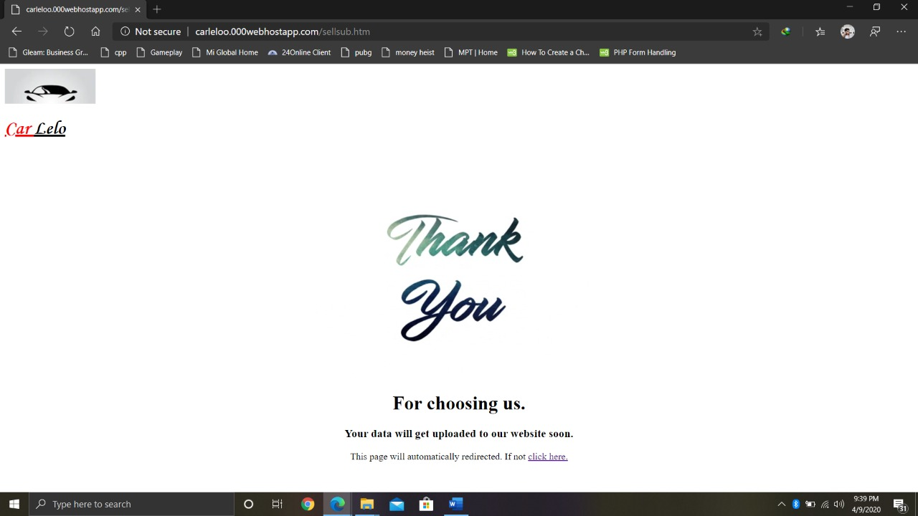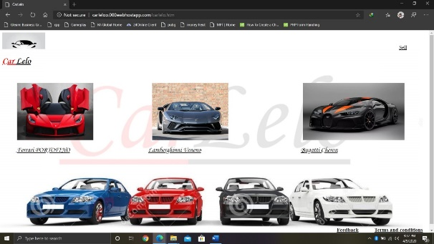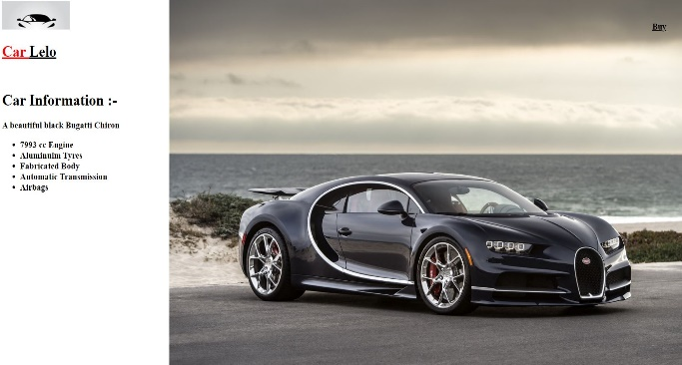

***FINAL REPORT OF CSE 326***

Our website is major collection of creative webpages.

We will give you the details by using screenshot of our webpages.

Here the journey began of our website…….

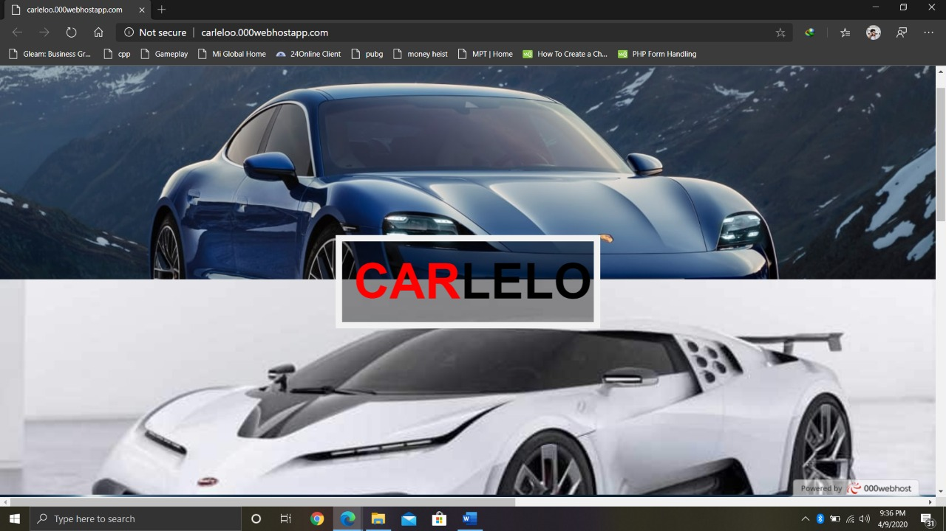

This is the first page you will encounter .It is not our home webpage but here you will get the pics of cars which we are selling now a days.

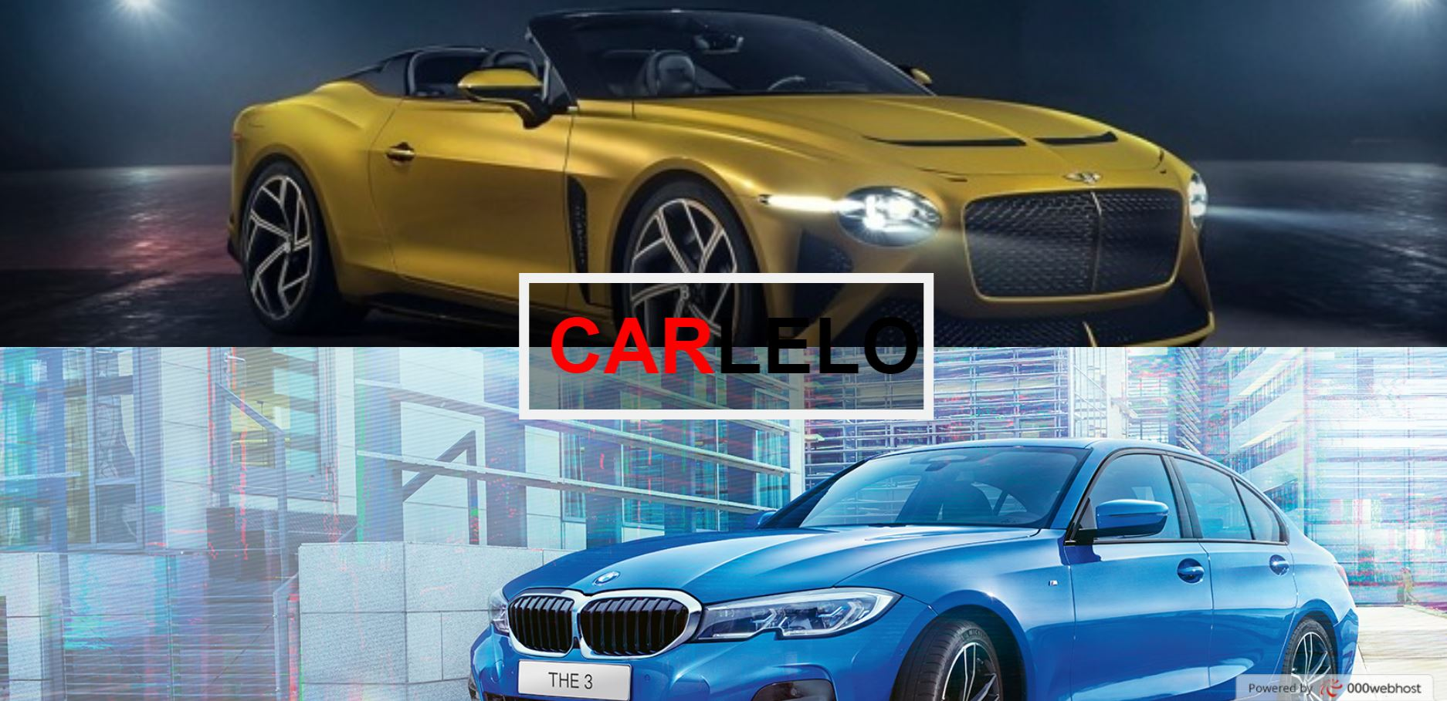

***I will make you familiar with some images***

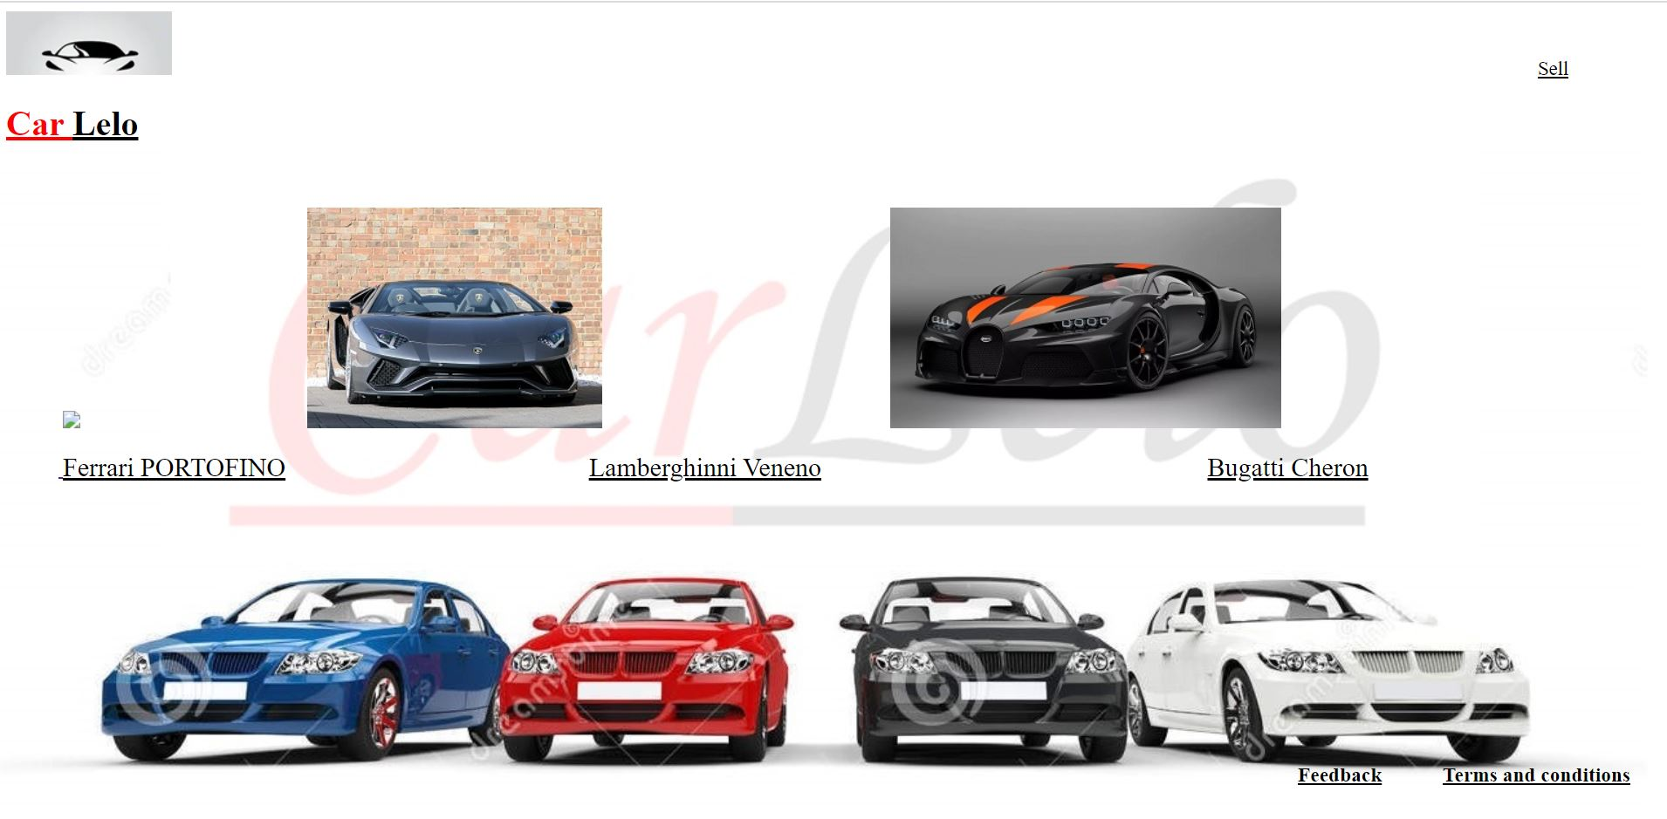

This is our website logo. Whenever you will click on this image you will land on home page.

This is another logo and name of our website. Here also if you click on this you will come to home page.

This image is a main background image of our website.

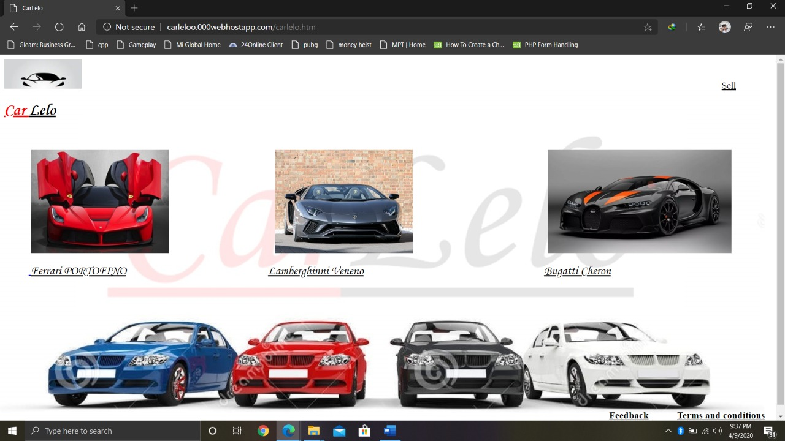

* This is the home page of our website. We have logo of our website which you can see in the background.
* Here you will get the car which you want to buy.
* First of all, website logo and Car Lelo name of every webpage are hyperlinked to this home page.
* Car image and its name are hyperlink. This hyperlink will transfer you to buy page.
* In right bottom corner you will get the section of feedback and Terms and Conditions

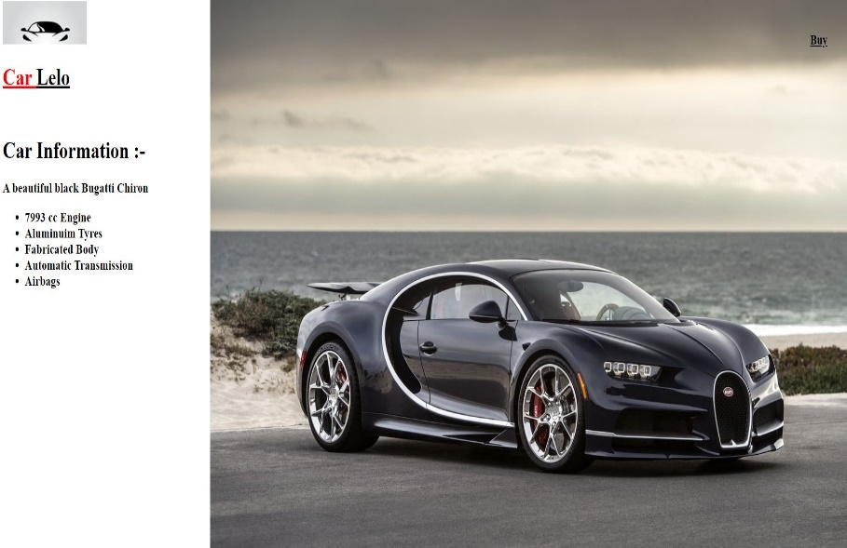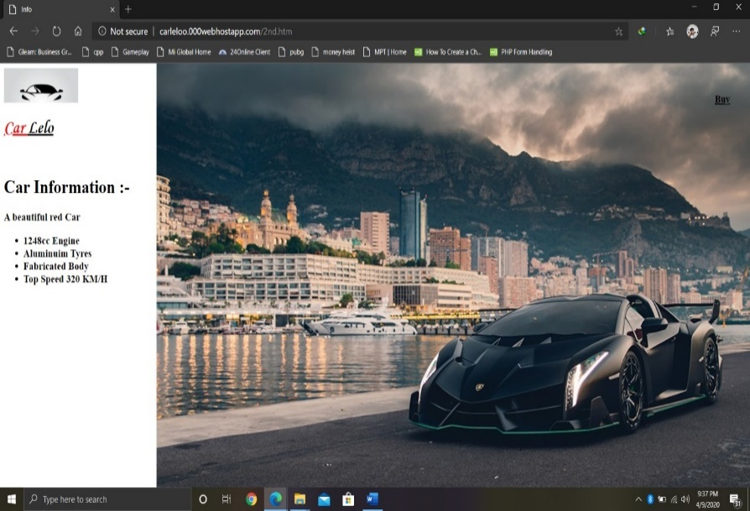

* If you click on any car of home page , you will land here.
* Here we shown the details of car and image also.
* 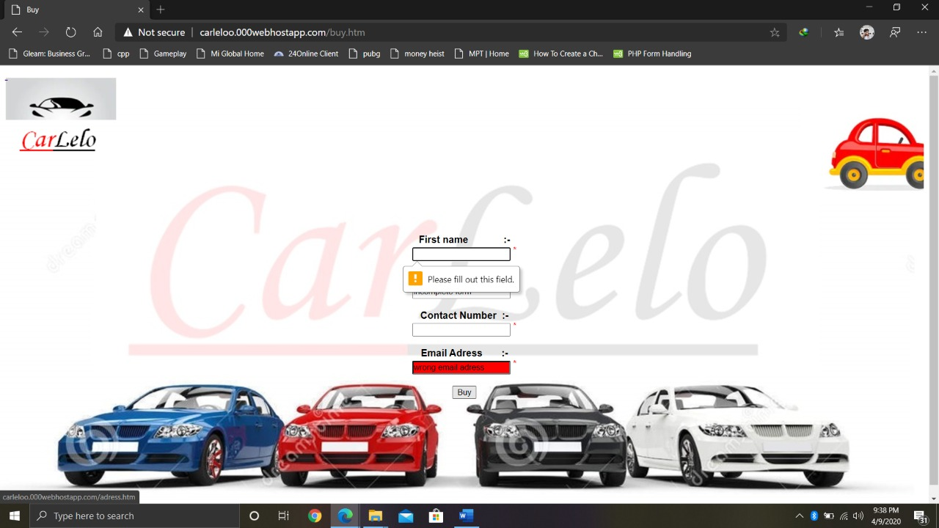In right top corner we have a buy option .
* Here is the buy page. You have submit your contact details so that we can deliver the car to your house.
* All the details are mandatory, as you can see there is an alert coming “Please fill out this field”.
* There is a car in the top which is moving from left to right.
* Script for correct Email has been used, whenever the user type wrong mail id it will become red in colour.

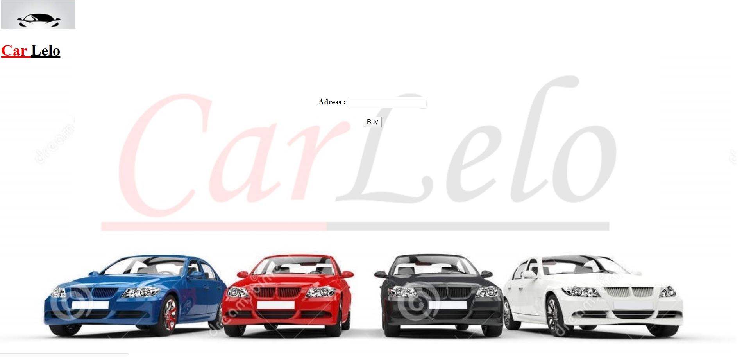

* After the buy page you will come to this page for enter address.

* After submitting all the details you will see final page of buy.
* There is a video on packing your car. This page will automatically redirect to home page or you can click also to go home page.

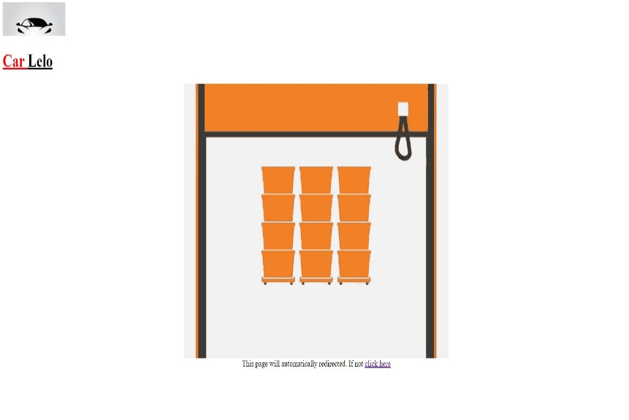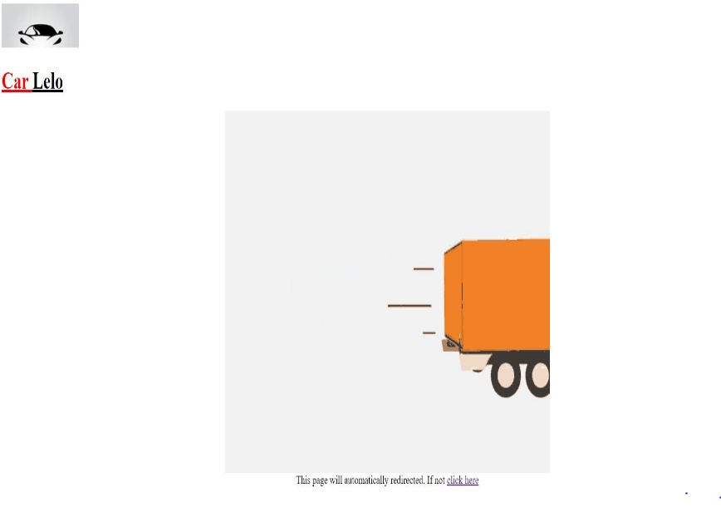

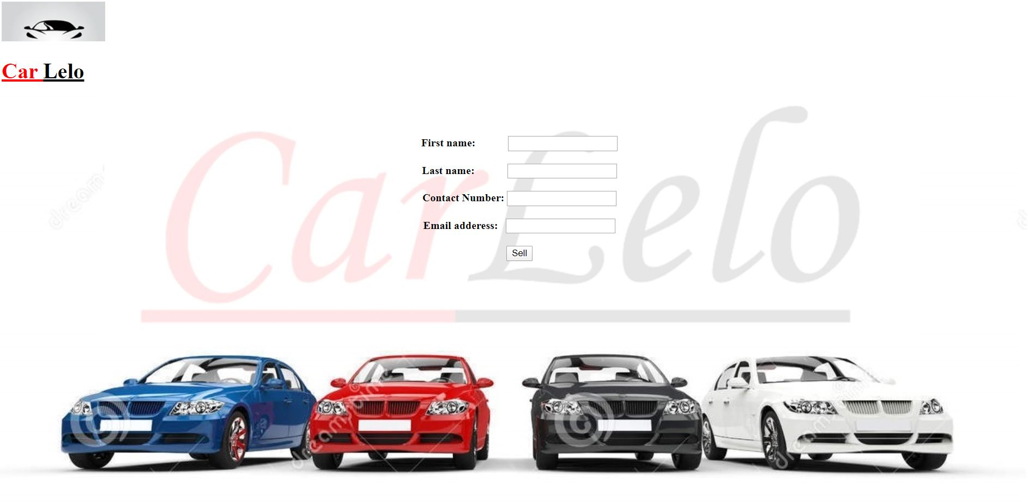

* This is page for selling any car .
* Here also all the fields are mandatory to fill.
* Script is used to enter the price by the seller.

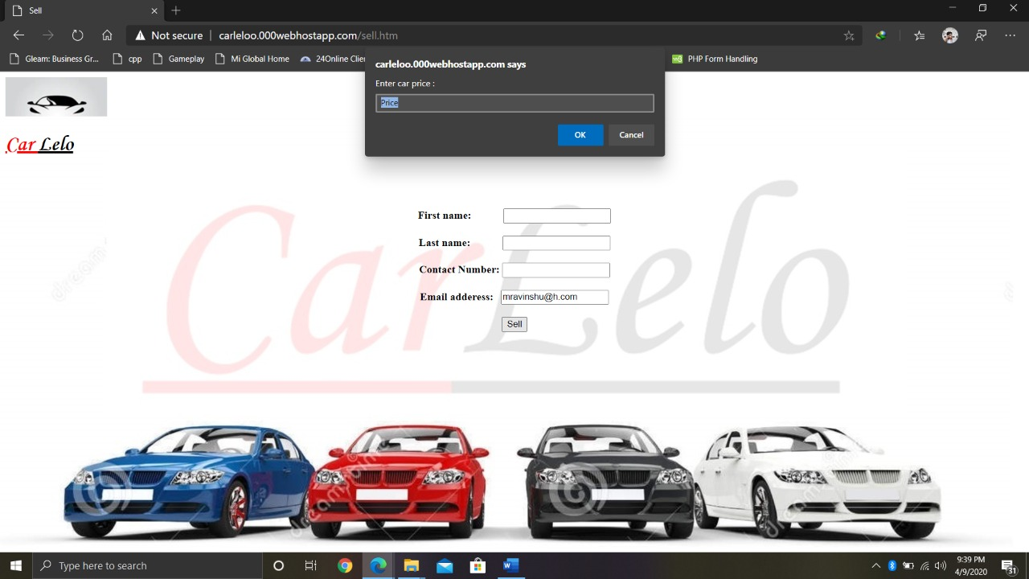



* After that last page of sell will come .
* Here we thanks to our customer for choosing us.
* 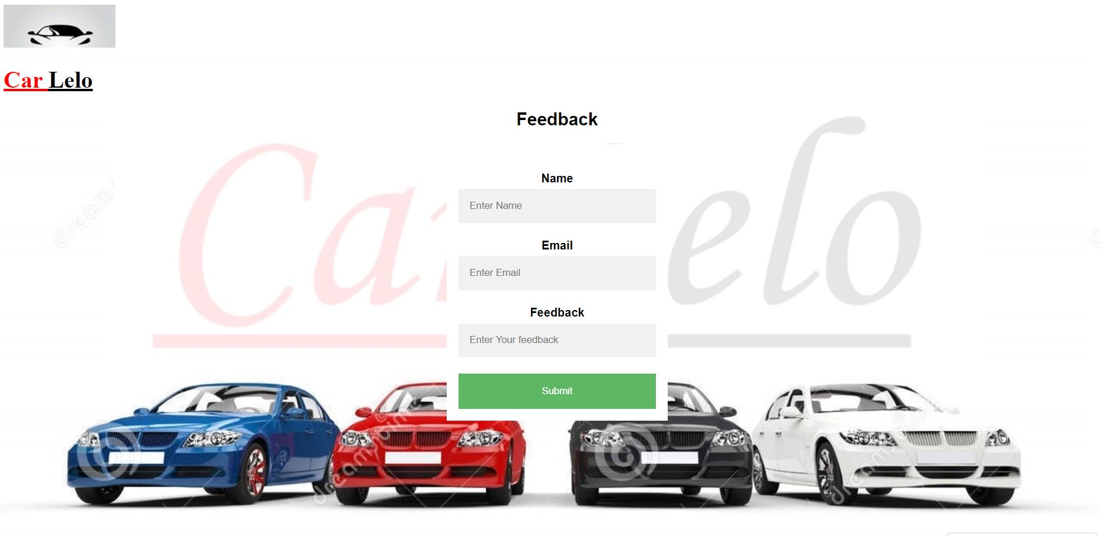This page is also redirect to home page or you can also click to go to home page.
* Our website is also consist of feedback page .
* Here you can give your valuable feedback to us, so that we can improve our website to the best.
* After submitting these detail you will come back to the home page.

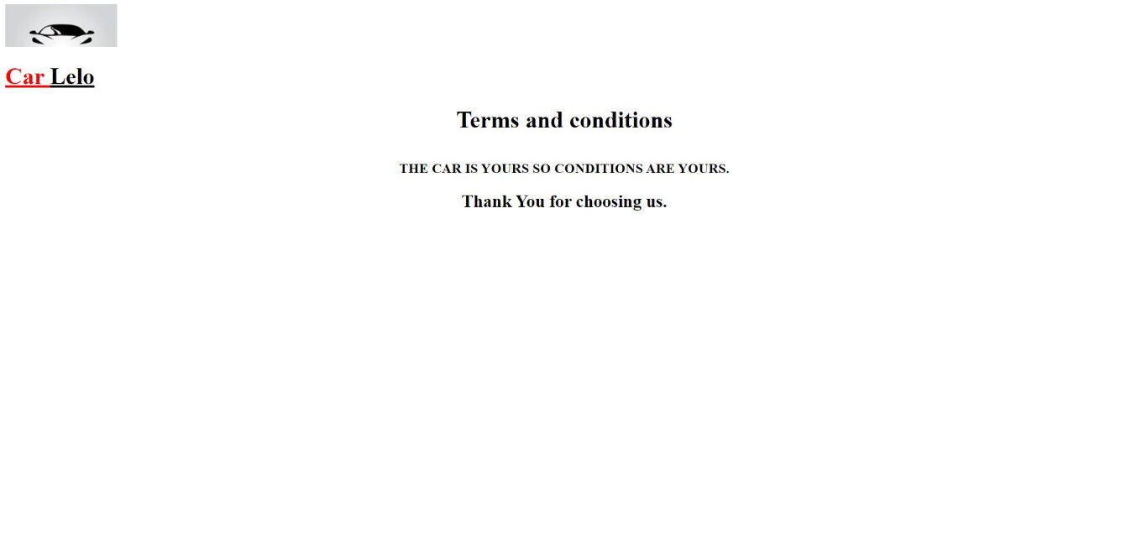

* This is the last page of our website.
* Here we have written that “The car is yours so condition are yours “ means that we don’t have any condition and that is the best thing our company.

***Flow charts***

***Drawback***

* The one flaw with the internet is it is not everywhere yet. If your internet goes down or you happen to be in an area that has not been connected yet you will not be able to access the website.
* There is no denying that your data is less secure when it’s in the cloud, especially when users from all over the world are accessing the same server hosted by a third party. Although there are ways to reduce your risk, email encryption and SSL enforcement for secure HTTPS access are just two examples.

***Contribution of members***

***Priyanshu :*** Complete work of sell page , feedback. All the hyperlinks done by him. Scripts of sell pages. Content of final report with screenshot of webpages.

***Ravinshu :***  Complete work of home page and complete buy pages. Scripts of buy pages. Content of final report.

**Ketan Nalwaya :** Terms and condition page and collection of some pictures and help the group in making final report.

After the basic structure was completed . we all started implementing the css and java to different pages.

We **(Priyanshu & Ravinshu)** discuss how to redirect to home page and we used it also in our website.

In last we all have contributed almost equally in making this website.

***THANK YOU***